**Technical Analysis Report**

# INTRODUCTION

This report presents a comprehensive analysis of San Francisco’s building permit data to understand the factors influencing permit approval times, construction costs, and development patterns across the city. The dataset, obtained from the San Francisco Open Data Portal, includes information on permit types, estimated costs, approval dates, building characteristics, and neighborhood locations.

Through data cleaning, transformation, and exploratory analysis using Python and Power BI, this study identifies trends, delays, and cost variations in the city’s permit system. The findings aim to support data-driven decision making for improving permit efficiency, enhancing transparency, and guiding future urban planning efforts.

# PROBLEM STATEMENT

Getting construction permits in San Francisco is often slow, unpredictable, and unclear. For example, the 33 Tehama Street building faced long permit delays after a water leak, leaving the building empty, work stopped, and millions lost.

# OBJECTIVES

* Identify the most and least common permit types in San Francisco and their locations.
* Analyze the average approval time for each permit type in San Francisco.
* Identify the most common building floors in San Francisco permit applications.
* Analyze yearly trends in permit applications.
* Analyze permit types by Actual cost.
* Identify the top 10 neighborhoods by proposed units.

# TARGET AUDIENCE

* Government officials & city planners
* Construction companies

# DATASET

The dataset includes details of all building permit applications filed with the Department of Building Inspection. Permit numbers and associated information may be repeated in multiple rows if there are multiple addresses associated with the permit. The dataset is created by extracting permit characteristics and key dates (including permit filing, issuance, and completion dates) from DBI’s Permit Tracking System.

Data Source: https://www.kaggle.com/datasets/aparnashastry/building-permit-applications-data

A full data dictionary for this dataset is available by [clicking here](https://drive.google.com/drive/folders/1nV0_rTSqZotPbRPmM2bmHQlLpyk-pkhU?usp=sharing).

# DATA HANDLING

1. Converted date columns to datetime format.
2. Handled missing and null values across multiple fields.
3. Standardized text entries (e.g., replaced "Y" with "True").
4. Removed duplicate records.
5. Calculated new fields:

Days_to_Issue → Permit approval time.

Year → Extracted from Permit Creation Date.

1. Filtered out outliers and unrealistic date or cost values.

# ANALYSIS AND FINDINGS

* 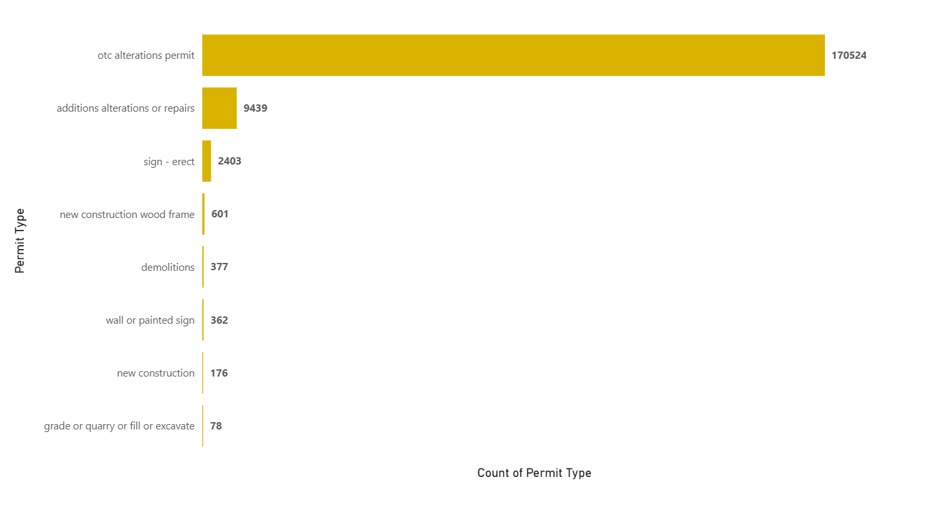Most Common Permit Types in San Francisco
* Approval Time by Permit Type

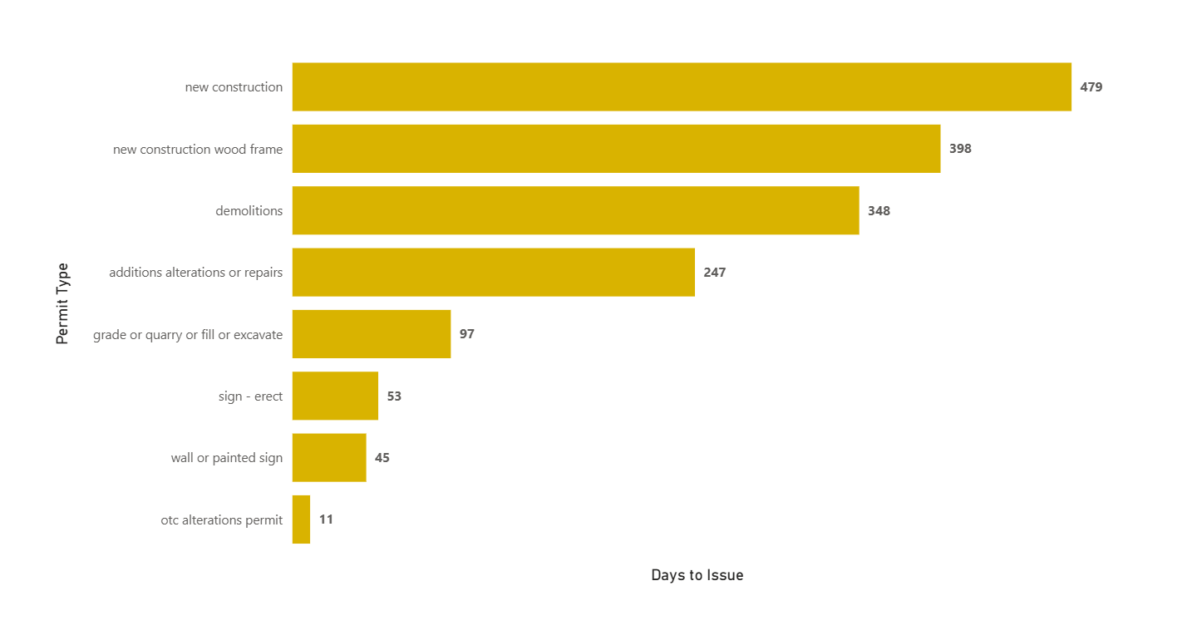

* New Construction Permit Over Time

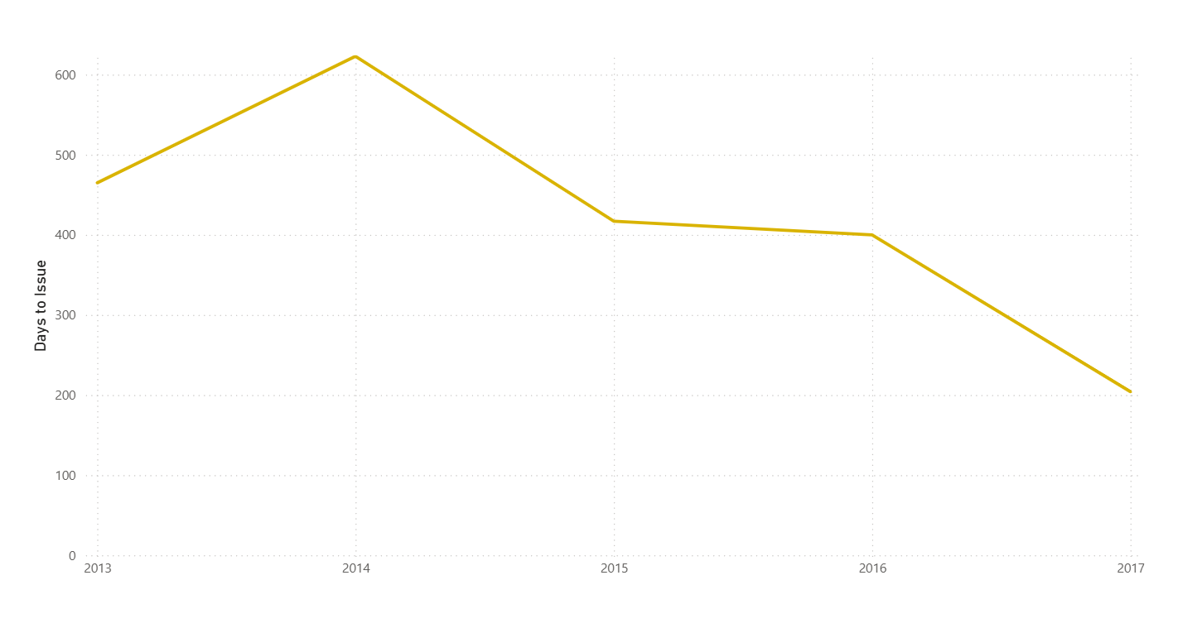

* The Rise of San Francisco: Floors by the Numbers

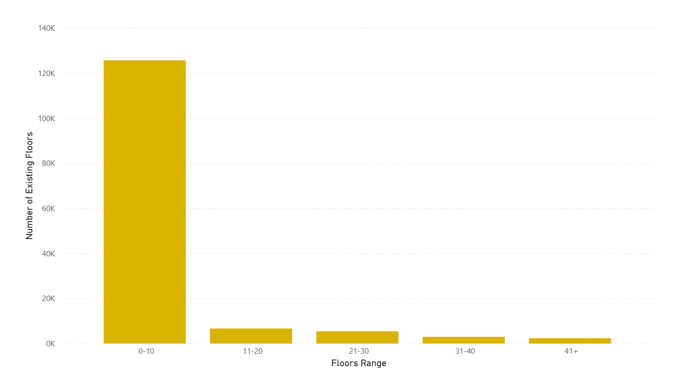

* Trends in Permit Applications Over Time

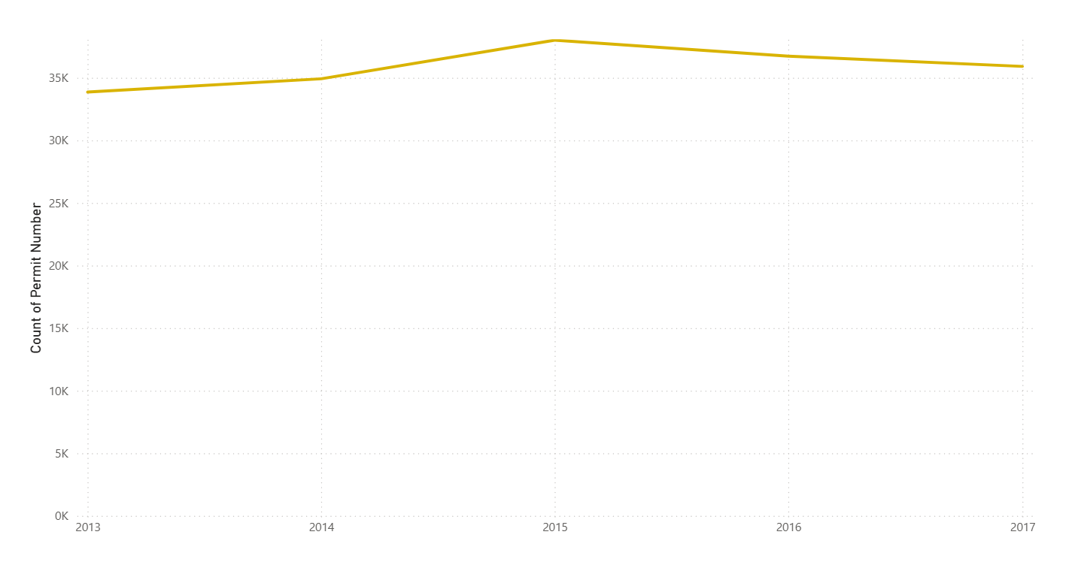

* How Much Does It Cost to Build in San Francisco?

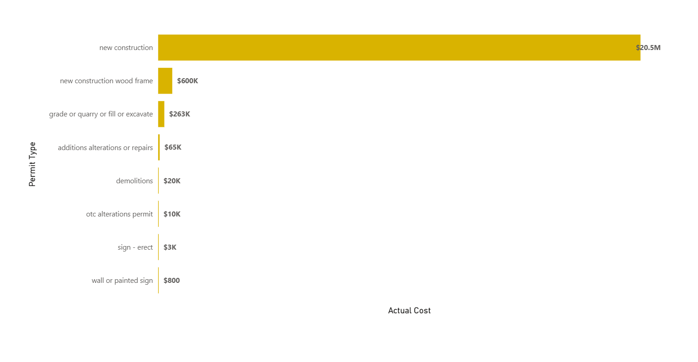

* Where San Francisco Is Growing: Top 10 Neighborhoods by New Units

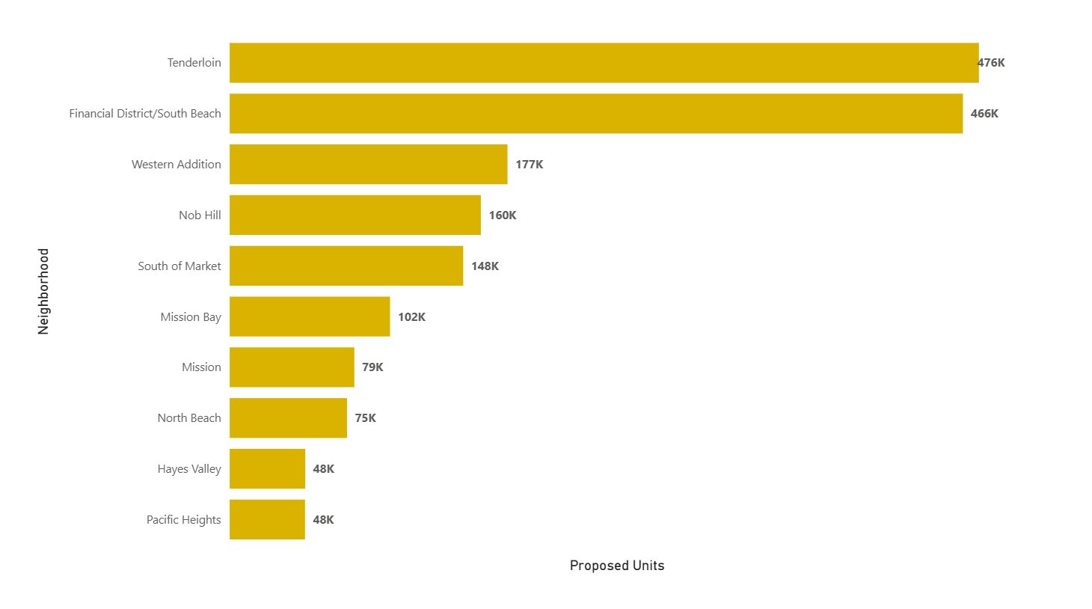

* Neighborhoods with the Most Building Permits

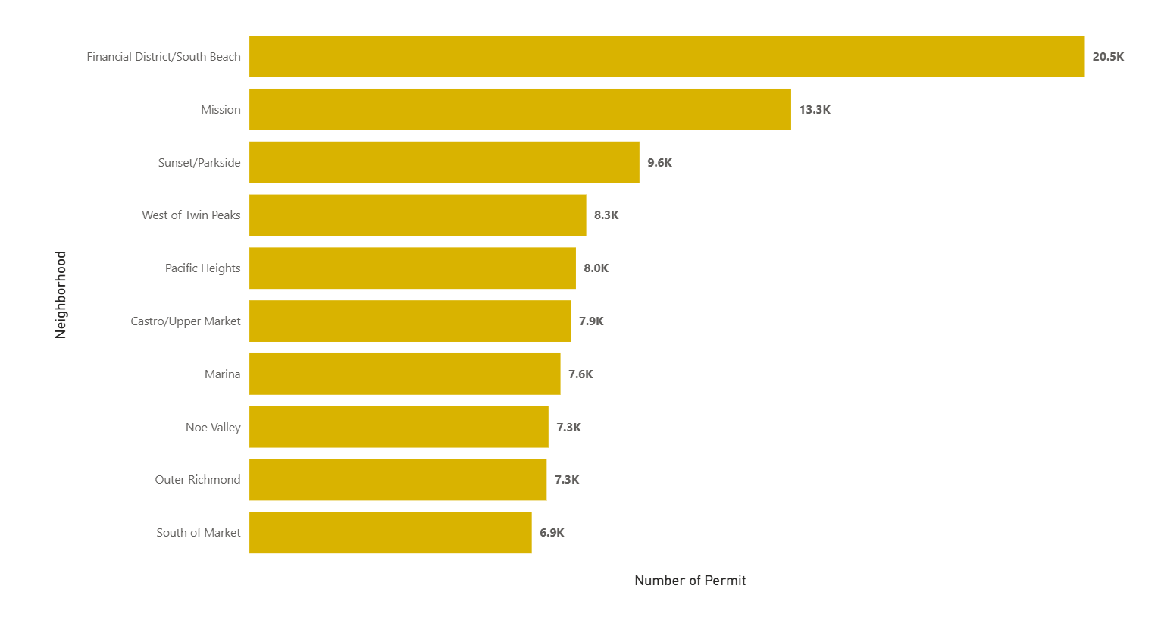

* Most Common Permit Types in Financial District

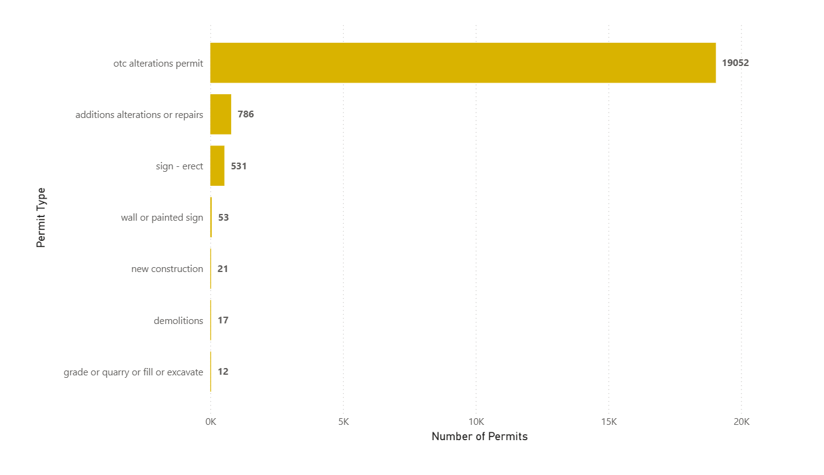

* Yearly Trend of OTC Permit in Financial District

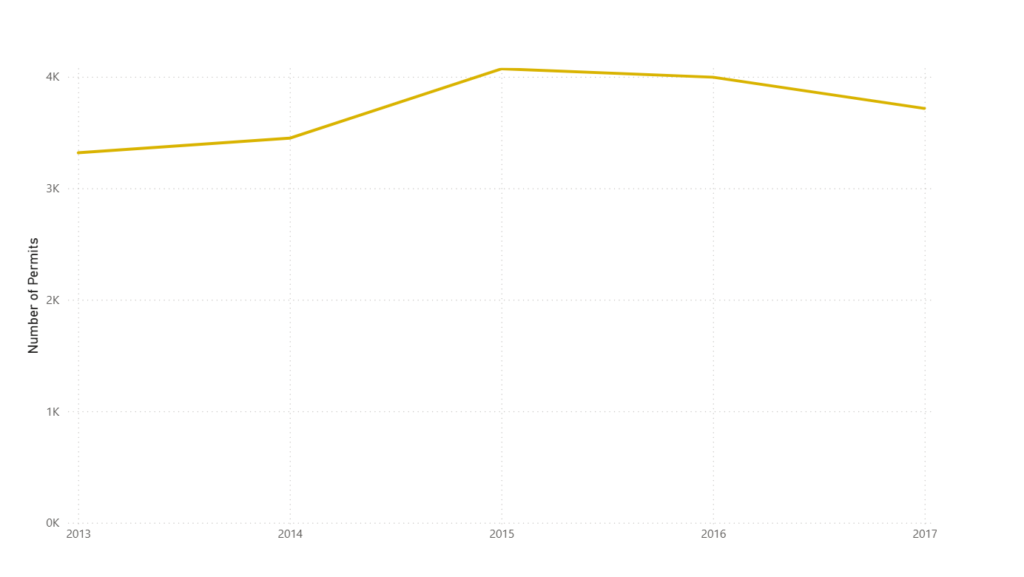

* Actual Cost Trend for OTC Permit in Financial District

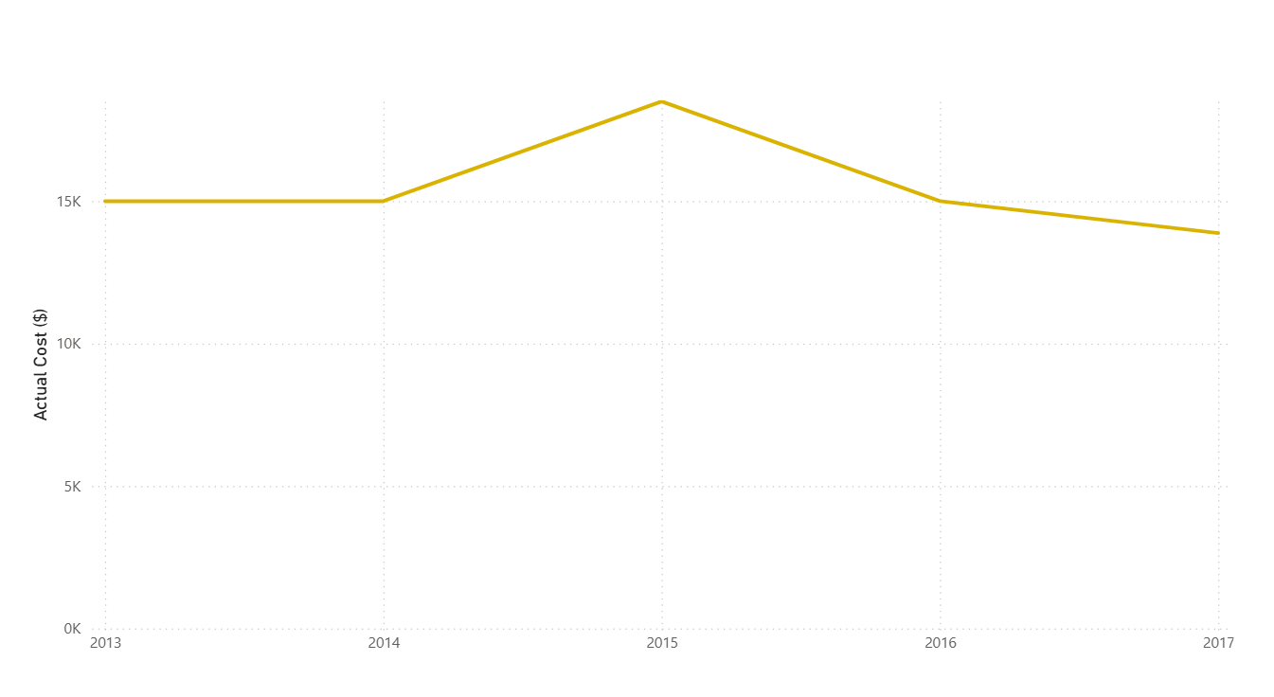

# RECOMMENDATIONS

* Resource prioritization: allocate more staff to review complex or high cost projects faster.
* Transparency: make approval timelines and requirements clearer to reduce confusion.
* Periodic audits: review slow permit categories annually to identify bottlenecks.
* Neighborhood monitoring: track trends in high activity areas to guide urban planning.

# REFERNCES

]1[ <https://www.sf.gov/departments--department-building-inspection>

]2 [https://www.biv.com/news/economy-law-politics/city-building-permit-delays-costing-developers-tim-8241390

]3 [ https://data.sfgov.org/Housing-and-Buildings/Building-Permits/i98e-djp9/about_data